Program Information | [Lesson Title]  Text Structure and Organization |  |  |  | TEACHER NAME  Stacey Jones |  |  |  |  | PROGRAM NAME  Mid-East Career and Technology Centers
Program Information | [Unit Title]  Analyze Text Structure |  |  |  | NRS EFL(s)  3 |  |  |  |  | TIME FRAME  180 minutes over multiple classes
Instruction | OBR ABE/ASE Standards – English Language Arts and Literacy
Instruction | Reading (R) |  | Writing (W) |  | Speaking & Listening (S) |  |  |  | Language (L)
Instruction | Foundational Skills |  | Text Types and Purposes | W.3.2 | Comprehension and Collaboration |  |  |  | Conventions of Standard English
Instruction | Key Ideas and Details |  | Production and Distribution of Writing | W.3.3 | Presentation of Knowledge and Ideas |  |  |  | Knowledge of Language
Instruction | Craft and Structure | R.3.10  R.3.11 | Research to Build and Present Knowledge |  |  |  |  |  | Vocabulary Acquisition and Use
Instruction | Integration of Knowledge and Ideas
Instruction | LEARNER OUTCOME(S)  - Students will examine the organizational structures of description, sequence (chronology), comparison, cause and effect, and problem or solution in multiple texts. |  |  |  |  | ASSESSMENT TOOLS/METHODS  - Teacher Observation  - Description, Sequence, Comparison, Cause and Effect and Problem or Solution Graphic Organizers  - Text Structure Exit Slip  - Interactive Text Structure Quiz  - Text Structure Chart  - Short-Answer Response Writing
Instruction | LEARNER PRIOR KNOWLEDGE  - Students may be familiar with organizational methods, but they may be unfamiliar with the words that identify such organization (chronological, compare and contrast, cause and effect, description, and problem-solution). Students will need to review these terms.
Instruction | INSTRUCTIONAL ACTIVITIES  - Begin the lesson with discussion on the organizational structure of texts. Instructor will explain that writers use different text structures (like description, sequence (chronology, order), comparison, cause and effect, and problem or solution) to organize the ideas within their writing.  - Description - Sensory and descriptive details help readers visualize information. It shares the ‘who, what, where, when, why, and how’ of a topic/subject.  - Sequence - Sequence of Events: Chronological texts present events in a sequence from beginning to end.  How-To: How-To texts organize the information in a series of directions.  - Comparison - Authors use comparisons to describe ideas to readers. Similarities and differences are shared.  - Cause and Effect - Informational texts often describe cause and effect relationships. The text describes events and identifies reasons (causes) for why the event happened.  - Problem or Solution - The text introduces and describes a problem and presents one or more solutions.  Instructor will also point out that students will in some cases be able to identify a text structure by looking at multiple texts and explain that we will be focusing on description, sequence (chronology, order), comparison, cause and effect, and problem or solution.  - The class will watch the YouTube video Identifying Text Structure and discuss the contents of the video.  - Students will be given the opportunity to practice using graphic organizers as they read each of the five kinds of text structures. The instructor will model reading and working with each particular kind of text in order to complete the graphic organizer selected for that text type.  Teacher Note Additional passages can be found at Pure Text Paragraphs for students needing additional practice with a particular structure.  Description Model how to identify an organizational structure of the text using Jupiter which exemplifies this text structure. Instructor will go through the text sentence by sentence and point out the words in the sentence that signal text structure. Model using highlighters or pens to mark the text. Using classroom technology, display the Concept Map graphic organizer as you complete as part of the think aloud.  Students are given the Concept Map graphic organizer as they read and find information in the Humpback Whales article. They can work individually or in pairs to complete the reading.  Sequence (chronology) Model how to identify an organizational structure of the text using Harry Houdini which exemplifies this text structure. Instructor will go through the text sentence by sentence and point out the words in the sentence that signal text structure. Model using highlighters or pens to mark the text. Using classroom technology, display the graphic organizer as you complete as part of the think aloud.  Students are given the Chain of Events graphic organizer as they read and find information in the Riparian Buffer Zone article. They can work individually or in pairs to complete the reading.  Comparison Model how to identify an organizational structure of the text using Frogs vs. Toads which exemplifies this text structure. Instructor will go through the text sentence by sentence and point out the words in the sentence that signal text structure. Model using highlighters or pens to mark the text. Using classroom technology, display the graphic organizer as you complete as part of the think aloud.  Students are given the Compare and Contrast graphic organizer as they read and find information in the Fluttering Beauties article. They can work individually or in pairs to complete the reading.  Cause and Effect Model how to identify an organizational structure of the text using Sun Bear: An Endangered Species which exemplifies this text structure. Instructor will go through the text sentence by sentence and point out the words in the sentence that signal text structure. Model using highlighters or pens to mark the text. Using classroom technology, display the graphic organizer as you complete as part of the think aloud.  Students are given the Cause and Effect graphic organizer as they read and find information in the Old Batteries: A Nuisance or a Hazard? article. They can work individually or in pairs to complete the reading.  Teacher Note Several graphic organizers are included as use must be determined by each text according to number of causes and effects presented.  Problem or Solution Model how to identify an organizational structure of the text using Fast Food - Good or Bad? which exemplifies this text structure. Instructor will go through the text sentence by sentence and point out the words in the sentence that signal text structure. Model using highlighters or pens to mark the text. Using classroom technology, display the graphic organizer as you complete as part of the think aloud.  Students are given the Cause, Problem, Solution graphic organizer as they read and find information in The Flooded City article. They can work individually or in pairs to complete the reading.  - Students self-select texts from various websites. Find passages of interest to promote engagement with the text and to provide more meaning for students. Classroom reading passages can also be chosen based on level and interest. Students will have an additional copy of the graphic organizers and complete them as they read through their self-selected texts. Share completed graphic organizers with instructor and class.  - Students will complete a Text Structure Exit Slip after each of the five text structure activities.  Another informal evaluation option would be for students to complete the Interactive Text Structures Quiz online.  Students can complete the Text Structures chart where they provide the definition, signal words and list or draw the corresponding graphic organizer.  To reinforce the reading-writing connection, students write a paragraph using a specific text structure about a topic of their choice. Either or both can be assigned by teacher or chosen by the student. Higher level students could choose to write a short response to a prompt (based on a classroom reading passage), but use two different text structures to accomplish the writing. Paragraph one would use one of the five text structures studied and paragraph two would be written using another of the five.  Then, the third paragraph could analyze how the first two paragraphs (structures) compare and/or how they are different. |  |  |  |  |  | RESOURCES  Projector, ability to project  Computers for student use  Internet access  Identifying Text Structures Video. (n.d.). Retrieved from https://www.youtube.com/watch?v=zVU8xoXRHys  Highlighters for student use  Student copies of Description (attached)  Pure-Text Paragraphs [PDF file]. (n.d.). Retrieved from http://www.loudoun.k12.va.us/cms/lib4/VA01000195/Centricity/Domain/10408/Sample%20passages.pdf  Student copies of Concept Map graphic organizer (attached)  Concept Map [PDF file]. (n.d.). Retrieved from http://readingrockets.org/content/pdfs/conceptmap2.pdf  Student copies of Sequence (attached)  Pure-Text Paragraphs [PDF file]. (n.d.). Retrieved from http://www.loudoun.k12.va.us/cms/lib4/VA01000195/Centricity/Domain/10408/Sample%20passages.pdf  Student copies of Chain of Events graphic organizer (attached)  Chain of Events [PDF file]. (n.d.). Retrieved from http://www.educationoasis.com/curriculum/GO/GO_pdf/chain_events_2.pdf  Student copies of Comparison (attached)  Pure-Text Paragraphs [PDF file]. (n.d.). Retrieved from http://www.loudoun.k12.va.us/cms/lib4/VA01000195/Centricity/Domain/10408/Sample%20passages.pdf  Student copies of Compare and Contrast Chart Graphic Organizer (attached)  Compare and Contrast Chart [PDF file]. (n.d.). Retrieved from http://www.readwritethink.org/files/resources/printouts/CompareContrast.pdf  Student copies of Cause and Effect (attached)  Pure-Text Paragraphs [PDF file]. (n.d.). Retrieved from http://www.loudoun.k12.va.us/cms/lib4/VA01000195/Centricity/Domain/10408/Sample%20passages.pdf  Student copies of Cause and Effect graphic organizers (attached)  Cause and Effect [PDF file]. (n.d.). Retrieved from http://www.educationoasis.com/curriculum/GO/GO_pdf/causeeffect_2.pdf  Graphic Organizer: Cause and Effect Herringbone [PDF file]. (n.d.). Retrieved from http://www.creativewriting-prompts.com/support-files/causeeffect2herringbone6causeandeffect.pdf  Cause and Effects [PDF file]. (n.d.). Retrieved from http://www.docstoc.com/docs/13434577/cause-and-effect-graphic-organizers-%28pdf%29  Student copies of Problem or Solution (attached)  Pure-Text Paragraphs [PDF file]. (n.d.). Retrieved from http://www.loudoun.k12.va.us/cms/lib4/VA01000195/Centricity/Domain/10408/Sample%20passages.pdf  Student copies of Problem or Solution graphic organizer (attached)  Problems and Solutions Anchor Chart and Free Graphic Organizers. (n.d.). Retrieved from http://bookunitsteacher.com/flipchart/reading/textstructures/problemsolution.htm  Websites for students to self-select texts:  Reading Worksheets, Spelling, Grammar, Comprehension, Lesson Plans -. (n.d.). Retrieved from http://www.k12reader.com/  AwesomeStories: Story-driven teaching, learning, research, reading, writing. (n.d.). Retrieved from https://www.awesomestories.com/  Newsela | Nonfiction Literacy and Current Events. (n.d.). Retrieved from https://newsela.com/  Student copies of Text Structure Exit Slips (attached)  Text Structures Quiz. (n.d.). Retrieved from http://www.ereadingworksheets.com/text-structure-worksheets/text-structure-interactive-quiz.htm  Student copies of Text Structures chart (attached)
DIFFERENTIATION

- Students will work as a whole group during the modeling activity.
- They will work individually to select reading passages, mark the texts, and complete the exit slips.
- They may work in groups (if needed) or with the instructor (if needed) to facilitate their understanding of the activity.
- Graphic organizers provide a visual aid for building student knowledge base about the five text structures.
- A choice of informal assessments has also been provided.

Reflection | TEACHER REFLECTION/LESSON EVALUATION
Reflection | ADDITIONAL INFORMATION

Description

Jupiter
Jupiter is one of the nine planets in our solar system. It is called the giant among the planets because it has a diameter ten times as big as the earth. It also has twelve moons! Many scientists believe that the matter of which Jupiter is composed is in the form of a gas; it is not solid like the rock that makes up the earth and the moon. The truth in this hypothesis must await further exploration. Scientists do know that Jupiter’s rotation period is about ten hours, and its revolution period is about twelve years. This means that Jupiter spins very rapidly on its axis as it makes its orbit around the sun. The atmosphere surrounding this planet is probably made up mainly of ammonia and methane, and its temperature is far, far below zero. Since it has no water, no oxygen, and extremely low temperatures, it is unlikely that it could support life. This giant among planets does not seem like a friendly place for humans.
Humpback Whales
The humpback whale is huge. She is longer than a school bus and weighs 35 tons, but she preys on some of the smallest inhabitants of the sea world—tiny shrimp-like creatures that aren’t much bigger than a piece of popcorn called krill. To feed, she opens her mouth wide, taking in hundreds of gallons of water in a single gulp. A humpback whale has no teeth. Instead, attached to its upper jaw are rows of long, thin fingernail-like material called baleen. Each piece of baleen is about three feet long and has bristles at its end that act like a strainer. When the whale takes in a mouthful of water, it forces the water out through the baleen with its tongue, trapping thousands of tiny krill inside its mouth. Humpback whales eat A LOT of krill – up to 4,400 pounds per meal.

Pure-Text Paragraphs [PDF file]. (n.d.). Retrieved from http://www.loudoun.k12.va.us/cms/lib4/VA01000195/Centricity/Domain/10408/Sample%20passages.pdf

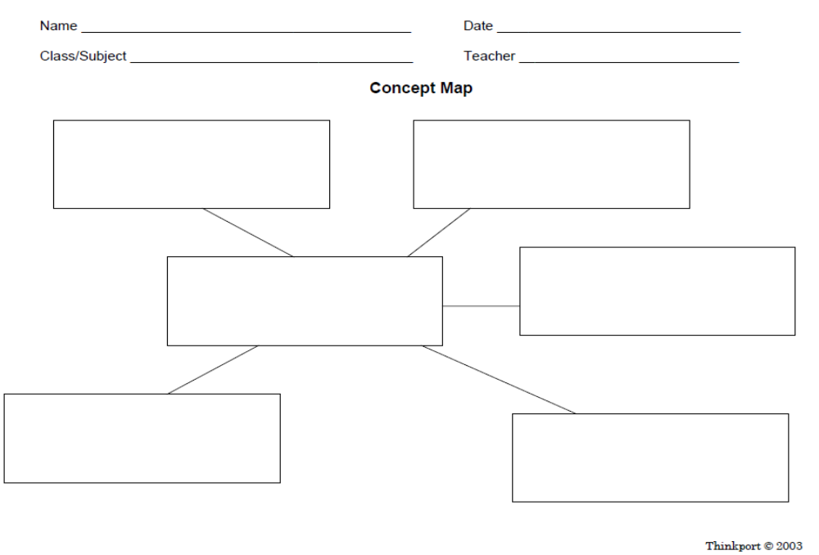
Sequence

Harry Houdini
Harry Houdini was born in Hungary in 1874 and moved to Wisconsin when he was four years old. As a young boy, he became captivated by magic when he saw a magician perform. Harry directed his energy to becoming a magician, but some of his first shows were a flop. After five years he almost gave it up. But the “needle trick changed all that. In this trick he swallowed needles and thread and coughed them back up with all the needles threaded through their eyes. Harry was on his way up! Harry went on to perform amazing stunts and tricks including in 1910 escaping out of the mouth of a cannon just before it blew up. No wonder Harry Houdini became a household name. Harry Houdini died on Halloween in 1926.

Riparian Buffer Zone
Planting a riparian buffer zone is easy, but requires some planning. The first step is to observe the area. What is already growing there? Next, decide what you would like to plant. Trees like river birches, pin oaks, and sycamores provide habitat for wildlife as well as a good buffer zone. A shrub like sweet spire is both ornamental and well-suited to the wet area. After you have decided on the plants, gather the necessary tools. Then you can get started on your riparian buffer zone!

Pure-Text Paragraphs [PDF file]. (n.d.). Retrieved from http://www.loudoun.k12.va.us/cms/lib4/VA01000195/Centricity/Domain/10408/Sample%20passages.pdf

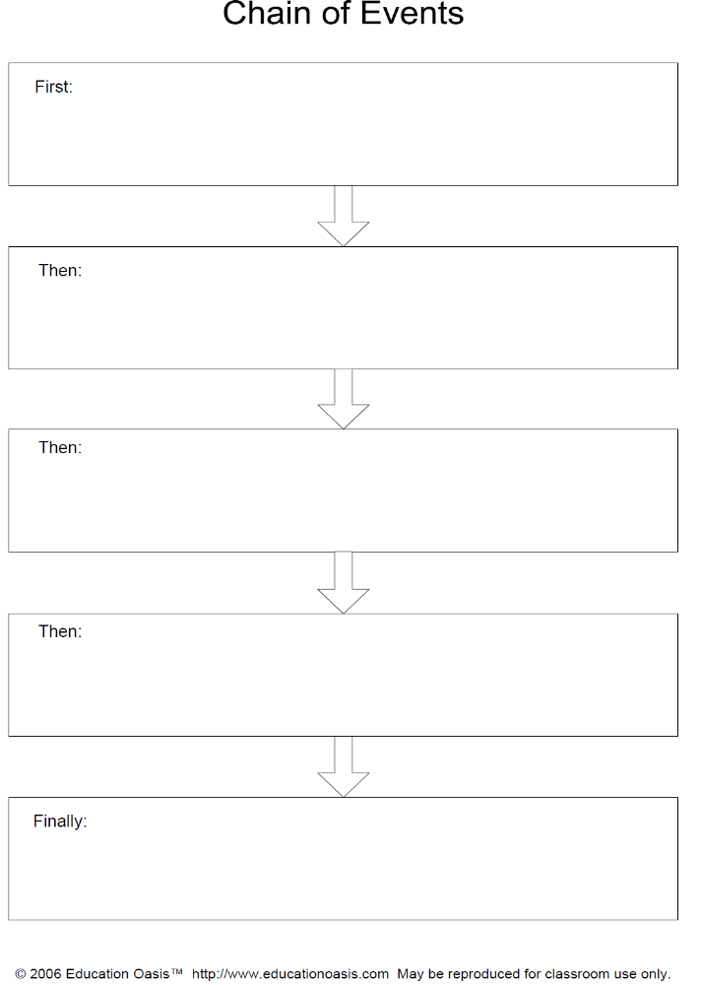
Comparison
Frogs v. Toads
You are walking along a pond when you see a frog – or is it a toad? How can you tell the difference? Frogs and toads have many physical attributes that can be used to identify which is which. Frogs have smooth skin, and rely on their large, powerful legs. Frogs are also, slimmer, smaller, and more streamlined than toads. Toads have warty skin in contrast to frogs. Toads are fatter and slower than frogs. Unlike frogs, toads can puff themselves up with air. Although frogs and toads are different, they also have some similarities. Both frogs and toads are classified as amphibians. They both have lungs, but can breathe through their skin. Using sounds to attract their mates is another similarity between the two. Toads and frogs both have diets that consist of insects, worms and more. As you can see, frogs and toads can easily be mistaken for one another, but when you know what to look for, telling the difference becomes easy.

Fluttering Beauties
You’re outside on a beautiful summer day. The light breeze brings the flutter of brightly colored wings. What is that lovely creature? Is it a butterfly or a moth?
Butterflies and moths are common insects. However, most people can’t tell them apart. They have many similarities. Both are insects. This means that they have three body parts and six legs. Also, both have large wings. Sometimes these wings are plain. Sometimes they are covered with fancy patterns.
But there are ways to know if you are looking at a butterfly or a moth. Some differences have to do with how the insects look. For example, butterflies have thin antennae. Moths have feathery antennae. You can see another difference in the wings. Butterflies have small scales on their wings. On the other hand, moths have larger scales. These scales make moths look fluffier than butterflies.
It can be hard to catch a butterfly or moth to take a close look at the antennae or wings! You can also look at how the insects behave to tell them apart. Most butterflies are active during the day, while most moths are active at night. Another behavior difference can be seen in the way that the creatures rest. Butterflies usually sit on a flower with their wings folded together. On the other hand, moths keep their wings spread out while resting.
Next time that you enjoy a lovely summer day, take a closer look at the winged beauties fluttering about. Are they butterflies or moths? Now you can decide.

Pure-Text Paragraphs [PDF file]. (n.d.). Retrieved from http://www.loudoun.k12.va.us/cms/lib4/VA01000195/Centricity/Domain/10408/Sample%20passages.pdf
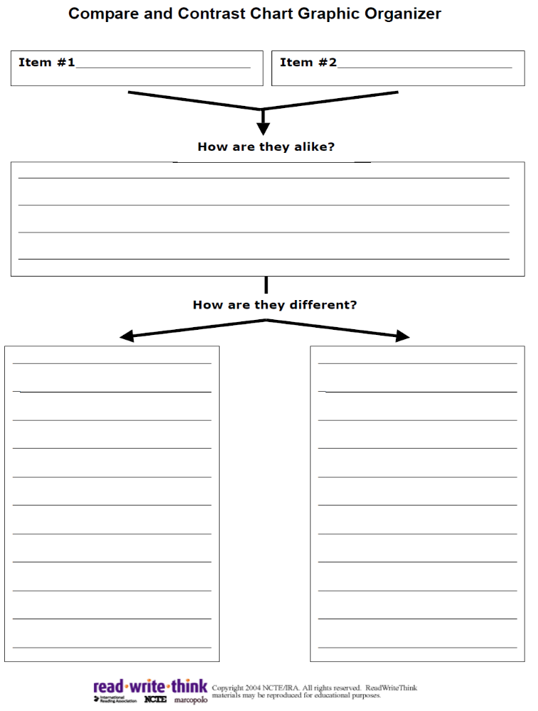
Cause and Effect

Sun bear: An Endangered Species
The sun bear, native to Southeast Asia, is an endangered species for two reasons. First, people in this part of the world hunt the sun bear for body parts such as the gall bladder, the claws and the meat. The body parts are valuable because some people believe that eating them will help heal broken bones and bruises. They believe this because the sun bear appears to fall out of trees without injuring itself. Additionally, special restaurants serve bear paws and bear meat to diners who think that eating this kind of meal will bring good health. In addition to being hunted, the sun bear’s habitat is being destroyed. The jungles where the sun bears live are being cleared to make way for homes and farms. Legendary beliefs can be harmful to nature.

Old Batteries: A Nuisance or a Hazard?
When batteries are thrown into the trash, they are harmful to the environment. If batteries are not properly disposed of, they can crack or become damaged. As a result, the toxic substances inside the batteries leak, and the surrounding water and soil are contaminated. Likewise, when batteries are incinerated, or burned, the air is contaminated by toxic fumes. Since incineration produces ashes, the ashes contain toxic substances. Over time, the ashes are buried and the toxic substances make their way into the soil and water. Finally, old car batteries are also harmful because they can crack open when they are dropped. If a neighborhood trash collector drops an old battery in the street or driveway, the toxic contents may spill and pose a health hazard for pets and small children. So it is very important to properly dispose of old batteries to protect our environment.

Pure-Text Paragraphs [PDF file]. (n.d.). Retrieved from http://www.loudoun.k12.va.us/cms/lib4/VA01000195/Centricity/Domain/10408/Sample%20passages.pdf
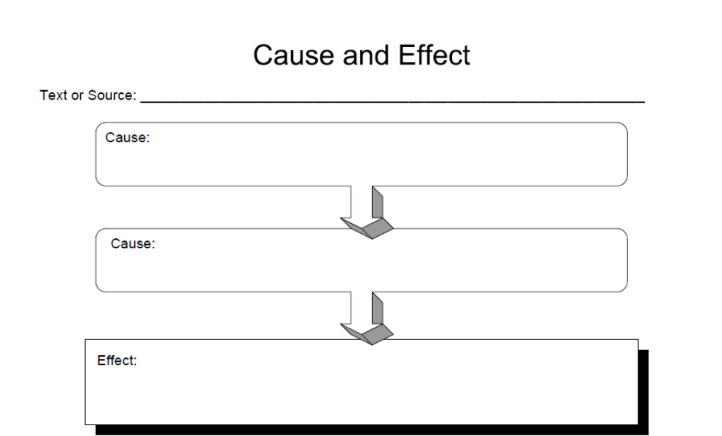

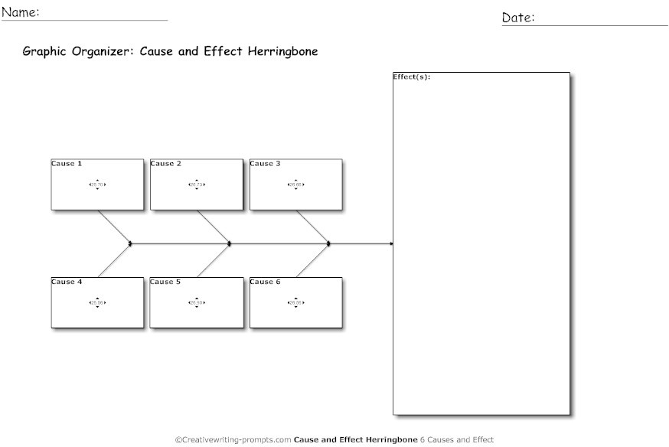
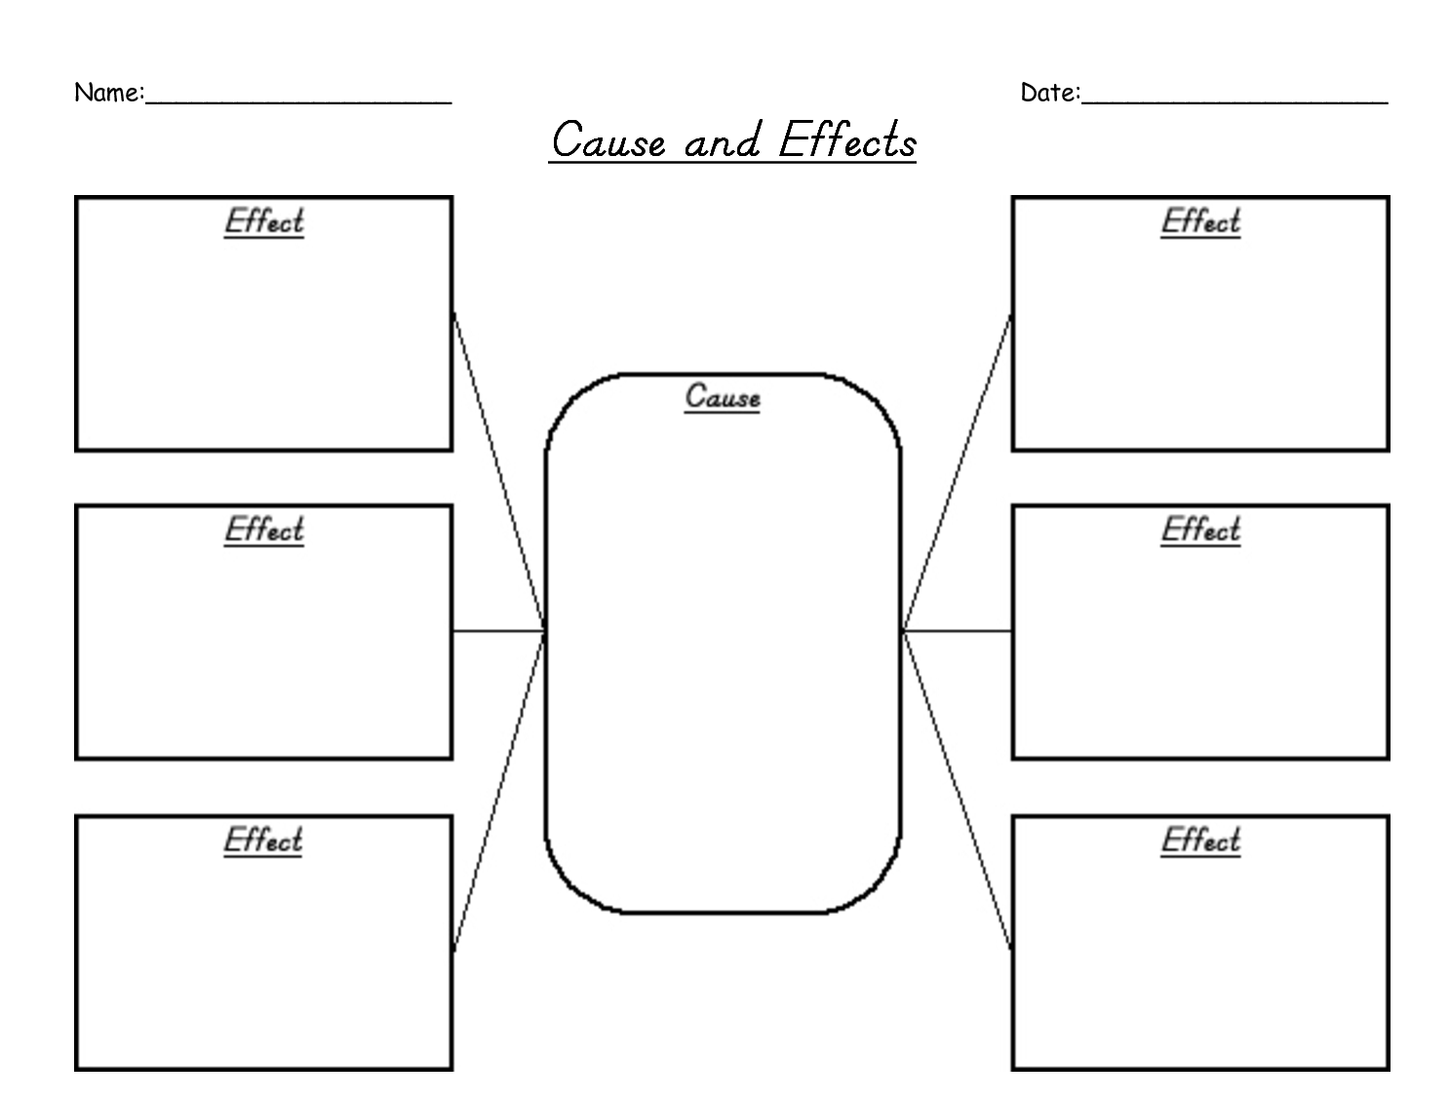

Problem or Solution
Fast Food — Good or Bad?
Fast food gets bad press these days, especially since it often contains too much fat, sodium and calories, but it brings much needed convenience to our stressful busy world. Fast food is easily found and varied. At any mall, for example, customers have many choices at the food court. To avoid too much fat or salt, they can choose healthier options: salads, turkey sandwiches and so on. On a busy Saturday, with two hungry kids, a mother out shopping is happy to find exactly the right food to eat. Not only that, but the food will be ready quickly, thus reducing the stress on her from demanding children. Fast food is also inexpensive; most menu items offer a full meal for under ten dollars. It is easy to see why fast food is so popular these days—it is convenient and reduces our stress.
The Flooded City
Venice is a very special city in Italy. What makes it special? Venice is almost completely surrounded by water!
Venice does have streets and roads like other cities. But Venice also has special waterways called canals. People use boats to move along these canals.
The people of Venice have always loved their city. Many people visit Venice to see the beautiful bridges and old buildings. There are hundreds of old houses, famous churches, and lovely fountains.
But the city of Venice is facing a problem. The tides are rising. Each day, there are two high tides. Each day, the water rises and covers streets and roads. The water comes up to the windows of buildings.
The problem is even worse when there are storms. Storms make tides even higher. The city of Venice could be completely flooded!
Scientists have worked to find a solution. They planned a set of 78 steel gates in the water outside of Venice. These gates will be able to open and close. When the water is calm, the gates will be open. But when there are storms, the gates will rise and protect the city.
Will the gates work? No one really knows. But the people of Venice hope that these gates will save their city from the high tides.

Pure-Text Paragraphs [PDF file]. (n.d.). Retrieved from http://www.loudoun.k12.va.us/cms/lib4/VA01000195/Centricity/Domain/10408/Sample%20passages.pdf

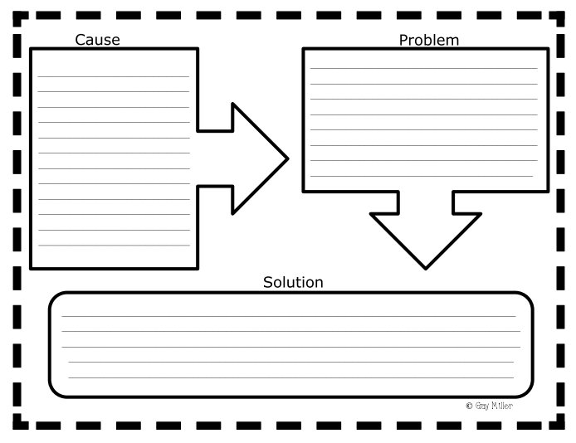
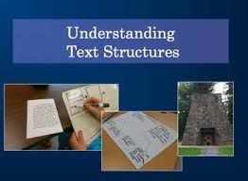
Text Structure Exit Slip

Today’s lesson was about ___________________text structure.
One key idea I learned today was ___________________________________________________________. This is important because __________________________________________________________________________________.
One question I still have about this text structure __________________________________________
___________________________________________________________________________________.
Name _________________________________________________ Date ________________________

Text Structures
Structure | Definition | Signal Words | Graphic Organizer
Description
Sequence
Comparison
Cause and Effect

Problem or Solution

